HAMAMATSU PHOTONICS launches innovative spectrometer with unprecedented dynamic range
_____________________________________________________________________________________________________
News provided by:
HAMAMATSU PHOTONICS Europe
May 22, 2023
Contact us
_____________________________________________________________________________________________________
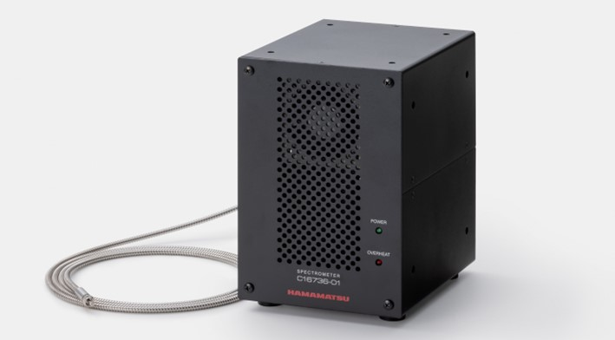
HAMAMATSU PHOTONICS, a leading manufacturer of high-performance photonic instruments, is proud to announce the launch of its latest Spectrometer - the OPAL-Luxe C16736-01.
With its unprecedented dynamic range of 2.5 Mio to 1, it is the first spectrometer to measure very weak signals and strong signals simultaneously within one device. This enables many new applications in the field of plasma physics, photoluminescence, optical density measurements and thin film metrology.
Innovative CCD Sensor design unleashes the Dynamic range
Spectrometers typically rely on the comparisons of signals. However, high-density samples or processes with simultaneous excitation and emission, such as plasma monitoring or photoluminescence, are difficult to access for spectroscopy as the intensities mustn’t differ too much to fit into the instrument’s dynamic range. To solve this issue, we developed an innovative CCD sensor design that enhances the dynamic range from a few tens of thousands to an unprecedented range of 2.5 million to 1. This becomes possible by dividing the CCD sensor into two areas, with each area having a separate exposure time for strong and weak signals. The two signals are then combined in the software, allowing for comparisons of multiple signals that differ in up to six orders of magnitude with excellent SNR.
The OPAL-Luxe Spectrometer uses Hamamatsu’s experience from previous spectrometer series, with improvements in the optical configuration enabling a wavelength resolution of 0.85 nm and a wavelength accuracy of 0.1 nm, without compromising sensitivity. The new optical design also reduces stray light inside the instrument, significantly improving the spectral SNR.
A versatile tool for Research and Industries
With these features, the OPAL-Luxe Spectrometer is ideal whenever two or more spectra of different intensity must be analyzed simultaneously. Especially interesting applications are laser-induced spectroscopy measurements, like photoluminescence spectroscopy or laser-induced breakdown spectroscopy (LIBS). In LIBS, a plasma emission of a sample is generated with the laser and measured to quantify the composition of materials. For an accurate measurement process, it is important to analyze the weak signals of molecular compounds in the presence of strong plasma signals from the atoms. While this is challenging for most spectrometers, it is the ideal application for the OPAL-Luxe and it can be a gamechanger for this promising analysis technology.
But also, other spectroscopic applications will benefit from our new innovative spectrometer. Measurements of high optical densities beyond the conventional limits for filter evaluation or absorption measurement of highly concentrated solutions, now become accessible. With its high dynamic range and the excellent SNR, the OPAL-Luxe eliminates the need for dilution steps or additional measurements. This simplifies the measurement, saves time in the procedure, and yields more precise results. Good reasons to integrate the OPAL-Luxe in a laboratory or production facility.

Key Features of OPAL-Luxe spectrometer C16736-01
- Unprecedented dynamic range of 2’500’000:1
- Excellent Signal to Noise Ratio thanks to an optimized, sealed housing with minimal stray light
- Wide spectral regime from 200 nm to 900 nm with high spectral resolution of typ. 0.85 nm
- High-speed observation at speed of up to 100 Hz

With the OPAL-Luxe HAMAMATSU PHOTONICS has developed a unique and powerful spectrometer that has the potential to enable many new fields of spectroscopic applications. And this is at the core of our philosophy: “We research light and utilize our discoveries to develop new products with the aim of challenging unexplored mysteries and create new future industries.”

Take your application to the next level by expanding the dynamic range of your measurements!
____________________
About HAMAMATSU PHOTONICS
HAMAMATSU PHOTONICS is a company driven by Japanese excellence and with a focus on research on “photons” or particles of light. Our products and technology include optical sensors, light sources, and systems that use these components. The products are applied to various new technologies and devices to support people’s lives and help realize a more comfortable and prosperous society. We take pride in the fact that our photonics technology is a Key Enabling Technology for great things. Our products are widely used for state-of-the-art medical equipment, test and inspection systems, microscopes that reveal the functions of cells, and giant telescopes that explore the mysteries of the universe. We work with you to make the impossible possible.
For further information, visit the product page here.
www.hamamatsu.com
_____________________________________________________________________________________________________
Key words: spectroscopy, laser-induced breakdown spectroscopy, LIBS, photoluminescence, thin-film metrology, high dynamic range, low stray light | Contact us
Market: Material Analysis, Quality Assurance, Scientific Research
_____________________________________________________________________________________________________
More information from:
HAMAMATSU PHOTONICS Deutschland GmbH
Petra Genitheim (Public Relations)
Tel. +49 8152 375-171
Email: pgenitheim@hamamatsu.de

