PRESS RELEASE
mRC-KIT-900-TWIN – two chillers in one case
AMS Technologies Introduces Development Kit for Compact Water Coolers up to 900 W
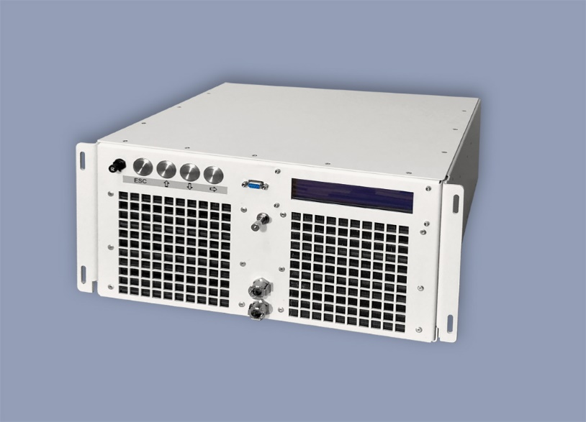

At LASER World of Photonics 2019, AMS Technologies presents the "mRC-KIT-900-TWIN", a "mini Recirculating Chiller" development kit which can be used to create particularly compact compressor-based water cooling systems. The kit combines two chillers with a total cooling capacity of 900 W in a 19-inch case. Overpressure on the water circuits ensures low-vibration operation, enables extremely small water tanks and extends maintenance intervals.
For applications requiring high water cooling performance in the smallest of spaces, AMS Technologies presents "mRC-KIT-900-TWIN", a development kit for water coolers based on miniature compressors. This "mini Recirculating Chiller" development kit provides two independent water cooling systems in a 19-inch rackmount insert, which can provide a combined maximum cooling capacity of 900 W.
With this double chiller concept, mRC-KIT-900-TWIN can cool two heat loads independently of each other – with one chiller, for example, dissipating the heat of a laser pump diode, while the other keeps the laser cavity at the desired temperature. The target temperatures for each of the two heat loads can be set individually for this purpose.
The compressors’ BLDC motors are speed controlled by an inverter, eliminating annoying switching noise of hot gas bypass valves known from ON/OFF compressor systems. Throughout its speed range, the compressor twin pump design offers low vibration and low noise.

– 2 –
– 2 –
Since the water circuit is pressurized, the mRC-KIT-900-TWIN manages with very small tanks (2 x 275 ml) – without the risk of cavitation in the smoothly operating centrifugal pumps. In addition, the overpressure on the cooling system prevents the ingress of bacteria and oxygen, keeps the coolant clean and thus extends the maintenance intervals. The necessary pressure on the two water circuits of the mRC-KIT-900-TWIN is generated by an electric air pump, which is also used for automatic complete filling and emptying of the cooling water circuits and thus simplifies the maintenance of the system.
For customer requirements that cannot be covered by the "mRC-KIT-900-TWIN", our thermal management specialists at AMS Technologies are happy to develop a completely tailor-made solution and offer all services from development through to series production.
For more information see: https://www.amstechnologies-webshop.com/mrc-kit-900-twin-compressor-based-recirculating-chiller-sw10292

AMS Technologies at the LASER World of PHOTONICS 2019 trade fair
Hall B2, Booth B2/203

Contact:
AMS Technologies AG
Caspar Grote (Technical Editor)
Fraunhoferstraße 22
82152 Martinsried
Germany
phone +49 89 89 57 71 73
cgrote@amstechnologies.com, info@amstechnologies.com

About AMS Technologies: AMS Technologies is Europe’s leading solution provider and distributor for Optical, Power and Thermal Management Technologies.
For more than 35 years, AMS Technologies has supported the European market with leading, innovative technologies and products that allow our customers to take a prime position in their chosen markets.
AMS Technologies delivers solutions into a variety of high-tech markets, including renewable energies, medical, defence & aerospace, research & scientific and various other industrial segments. Our customer base consists of Europe’s largest leading technology corporations, a network of universities and research institutes as well as the most promising start-ups.
We thrive by working in a ‘customer first’ environment. Our pan-European customers are serviced from a network of local offices in Germany, the UK, France, Italy, Spain, Poland and Sweden, with a focused operations and logistics centre located in Munich, Germany.
For further information about AMS Technologies, please visit our website www.amstechnologies.com.

