PRESS RELEASE
Custom photonics and thermal solutions as well as PICs post-processing at AMS Technologies booth B2.203 at LWoP 2023

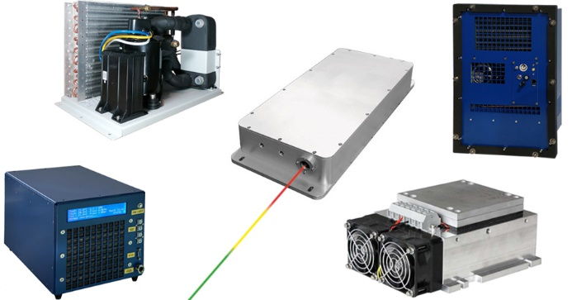

Martinsried, Germany, June 19th, 2023 – AMS Technologies, a leading provider of high-quality photonics products and solutions, is pleased to announce its participation in the upcoming LASER World of PHOTONICS 2023 exhibition, taking place from 27 to 30 June 2023 in Munich, Germany. The event promises to bring together the brightest minds and cutting-edge technologies in the field of photonics.
At Booth B2.203, AMS Technologies will showcase a range of exciting demonstrations that highlight the company's commitment to innovation and addressing industry challenges.

Customized photonics solutions
One of the featured demos shows the engineering capabilities of the design center to create highly customized photonics solutions by integrating a range of components and systems. The demo is focused on high-speed Laser Induced Breakdown Spectroscopy (LIBS), a technique revolutionizing material analysis. Visitors will have the opportunity to witness the speed and precision of this technology, which enables rapid elemental analysis for a wide range of applications.

Customized thermal solutions
Additionally, AMS Technologies will introduce its new 1kW Recirculating Chiller, a powerful but low noise and low vibration cooling solution designed to meet the demanding requirements of high-power laser systems. The demo will showcase the chiller's efficiency, reliability, and advanced features, which ensure optimal performance and temperature control in laser applications.
Furthermore, attendees will have the chance to experience a proof of concept for a 4 W @ -50°C Cascade Cooler, combining Peltier and compressor technologies. This innovative cooling solution demonstrates AMS Technologies' commitment to pushing the boundaries of thermal management for analytics, molecular reactors, rheology and viscosity measurement or wherever very low temperatures have to be maintained with moderate heat loads.

PICs post-processing: polishing, inspection and characterization
Another highlight of the exhibition will be AMS Technologies' solutions for post-processing around polishing, inspection and characterization of Photonic Integrated Circuits (PICs). With the increasing demand for PICs in various applications, efficient post-processing techniques are essential. The demo will showcase AMS Technologies' comprehensive range of solutions, including precision polishing tools, advanced inspection systems and testing equipment, enabling customers to optimize the performance and reliability of their PICs. AMS Technologies will also host a workshop dedicated to this topic during the show. Please see: https://epic-assoc.com/events/epic-technology-workshop-on-pic-post-processing-packaging-at-the-laser-world-of-photonics/

AMS Technologies encourages all industry professionals, researchers and customers with an interest in photonics to attend LASER World of PHOTONICS 2023 and visit Booth B2.203. Don't miss this opportunity to explore the future of photonics with our leading experts, witness our impressive demos and discover how AMS Technologies can empower your projects. To schedule a meeting with the AMS Technologies team and/or to receive a free ticket for the show please contact your local Sales office https://www.amstechnologies-webshop.com/contact-us

https://www.linkedin.com/company/ams-technologies-ag/
Booth B2.203

Contact:
AMS Technologies AG
Elisabetta Giubilato
Fraunhoferstraße 22
82152 Martinsried
Germany
egiubilato@amstechnologies.com, info@amstechnologies.com

About AMS Technologies
AMS Technologies is Europe’s leading solution provider and distributor for Optical, Power and Thermal Management Technologies.
For more than 40 years, AMS Technologies has supported the European market with leading, innovative technologies and products that allow our customers to take a prime position in their chosen markets. AMS Technologies delivers solutions into a variety of high-tech markets, including renewable energies, medical, defense & aerospace, research & scientific and various other industrial segments. Our customer base consists of Europe’s largest leading technology corporations, a network of universities and research institutes as well as the most promising start-ups.
We thrive by working in a ‘customer first’ environment. Our pan-European customers are serviced from a network of local offices in Germany, the UK, France, Italy, Spain, and Sweden, with a focused operations and logistics center located in Munich, Germany.
For further information about AMS Technologies, please visit our website www.amstechnologies.com

