PRESS RELEASE
mCTRL-T-20-12/55 – Cost-effective Miniature TEC Controller With H-Bridge
AMS Technologies Introduces Miniature Temperature Controller for Thermoelectric Coolers (TECs) or Peltier Elements
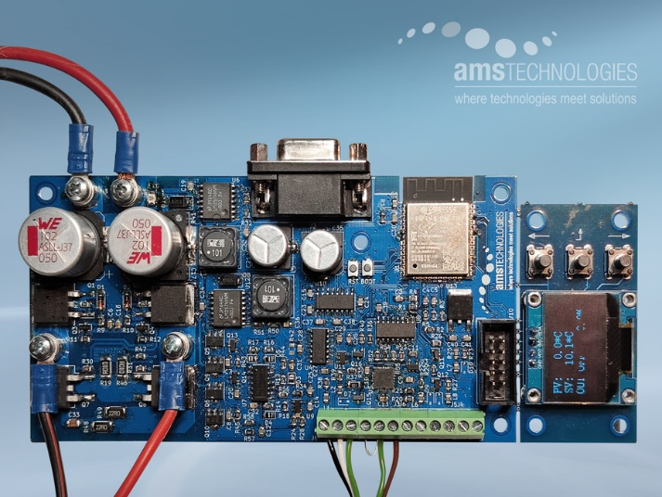

Martinsried, Germany, June 8th, 2023 – At LASER World of PHOTONICS 2023, AMS Technologies presents the "mCTRL-T-20-12/55", a low-cost miniature temperature controller. With its H-bridge output stage, the controller can drive thermoelectric coolers (TECs) or Peltier elements with currents up to 20 A and thus regulate their temperature with an accuracy of better than ±0.1°C.
The PCB format of AMS Technologies’ "mCTRL-T-20-12/55" allows easy integration of the miniature TEC controller into the user's circuits and systems. Voltage and current for the TEC can be adjusted over a wide range via the H-bridge in the output stage; the maximum output current is 10 A without or 20 A with heat sink.
A connectable temperature sensor (RTDs such as Pt100, Pt1000 or thermistor) allows highly accurate control of temperature within less than ±0.1°C. The user can set a target temperature value between -100°C and +100°C via analog interfaces such as 0-5 V or 4-20 mA, or via RS232 (serial), USB(VCP) or WiFi. The board’s layout allows the graphic OLED display to be detached, including the three operating keys, thus enabling OEMs to separate this operating unit from the main board and connect it via ribbon cable.
More information online: https://www.amstechnologies-webshop.com/mctrl-t-20-12-55-mini-tec-controller-ams-technologies-p000276-1
https://www.linkedin.com/company/ams-technologies-ag/
Booth B2-203

