PRESS RELEASE
mRC-C-1000-100/240 - Powerful Chiller Controls Temperature to within ±0.05°C
AMS Technologies Introduces Low-noise Water Cooler With 1000 W Cooling Capacity and High Temperature Stability
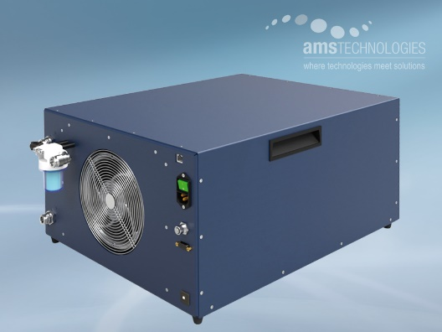
Martinsried, Germany, June 8th, 2023 – At LASER World of PHOTONICS 2023, AMS Technologies presents the "mRC-C-1000-100/240", a low-noise, compressor-based recirculating chiller with a cooling capacity of 1000 W that maintains a stable cooling water temperature to within ±0.05 °C.
The new system offers 1000 W water cooling capacity (at +35°C ambient and +25°C cooling water temperature) and thus rounds off AMS Technologies' range of recirculating chiller solutions in the high-power range. As with the "mRC-C-450-100/240" model, the recirculating chiller's compressor operates with efficient electronic speed control instead of the usual "on/off" operation with large hysteresis and disturbing switching noise due to hot gas bypass processes, thus offering extremely high temperature stability of ±0.05°C in steady state, with low vibrations and a low noise level.
With its integrated wide-range power supply – unusual for recirculating chillers of this performance class – running on 90 to 264 V AC, the mRC-C-1000-100/240 can be operated worldwide. Thanks to the optional Ethernet interface, the unit is "Internet of Things (IoT) ready" and can be remotely controlled, monitored and maintained via an internet browser.
The unit has been designed especially for low noise and low vibration environments. It therefore enables the use in applications where the chiller is integrated into OEM systems. AMS Technologies also provides a variant for operation on 24 V DC. For project requirements that the mRC-C-1000-100/240 does not cover, the thermal management specialists at AMS Technologies are happy to develop and manufacture customized systems for water cooling, tailored to the customer’s requirements.
For more information online: https://www.amstechnologies-webshop.com/mrc-c-1000-100-240-recirculating-chiller-ams-technologies-p000198-0

https://www.linkedin.com/company/ams-technologies-ag/
Booth B2-203

