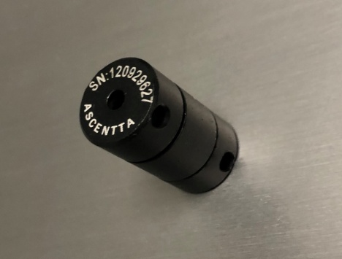

**650nm Mini-Size Free Space Isolator (TGG Type)**

Ascentta expands its product line with several new additions in time for Laser World of Photonics Munich 2019!

**650nm Mini-Size Polarization Dependent Free Space Isolator (TGG Type)**

Mini Package Size Φ13 x L23mm

Polarization Dependent with PBS Cube

Isolation (23℃) Typ. 25dB, Min 23dB

Optical Power Handling 5W

Visit us at Laser World of Photonics Munich June 24th to June 27th 2019 at Booth: B2.B2.125!

For more information please visit us at Ascentta.com or email us at [sales@ascentta.com](mailto:sales@ascentta.com)