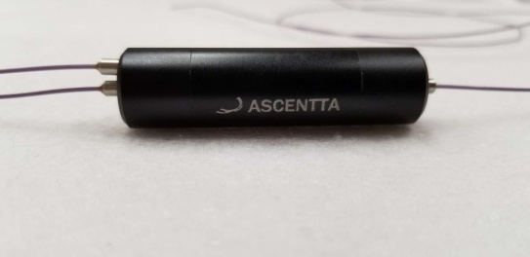

**1060nm PM High Isolation Circulator (TGG Type)**

Ascentta expands its product line with several new additions in time for Laser World of Photonics Munich 2019!

**1060nm Polarization Maintaining High Isolation Circulator (TGG Type)**

Isolation (23℃, All SOP) (2→1) Typ, 50 dB, Min. 45dB, Isolation (23℃, All SOP) (3→2) Min 25 dB

PM 980 Fiber

Package Size Φ24 x L80mm

Optical Power Handling 250mW

Visit us at Laser World of Photonics Munich June 24th to June 27th 2019 at Booth: B2.B2.125!

For more information please visit us at Ascentta.com or email us at [sales@ascentta.com](mailto:sales@ascentta.com)