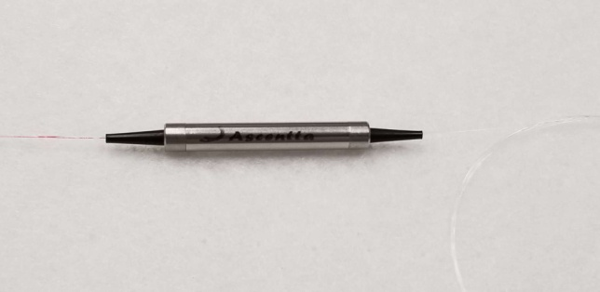

**1290-1620nm Ultra Broadband Single Mode Circulator**

Ascentta expands its product line with several new additions in time for Laser World of Photonics Munich 2019!

**1290-1620nm Ultra Broadband Single Mode 3-Port Circulator**

1290-1620nm

Isolation (All SOP) (2→1, or 3→2) Typ. 23dB, Min 20dB

Package Size Φ5.5 x L38mm

Optical Power Handling 300mW

Visit us at Laser World of Photonics Munich June 24th to June 27th 2019 at Booth: B2.B2.125!

For more information please visit us at Ascentta.com or email us at [sales@ascentta.com](mailto:sales@ascentta.com)