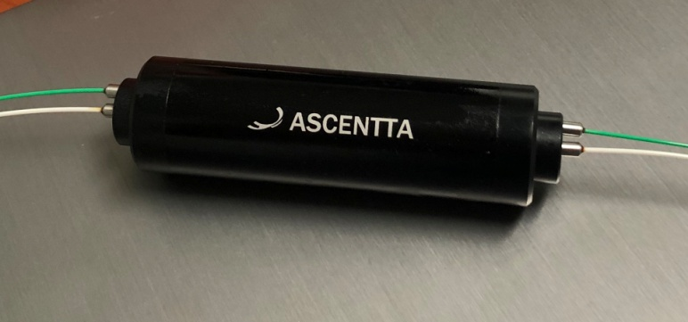

**850nm Two Channel Isolator Array (TGG Type)**

Ascentta expands its product line with several new additions in time for Laser World of Photonics Munich 2019!

**850nm Single Mode, Two Channel Isolator Array (TGG Type)**

2 Channels

Hi780 Fiber

Isolation (23℃, All SOP) Typ. 28dB, Min 24dB

Package Size Φ24 x L95mm

Optical Power Handling 150mW

Visit us at Laser World of Photonics Munich June 24th to June 27th 2019 at Booth: B2.B2.125!

For more information please visit us at Ascentta.com or email us at [sales@ascentta.com](mailto:sales@ascentta.com)