**LASER World of Photonics, Munich 24–27 June 2025 | Hall 3, Booth B313**

**Scansonic at LASER World of PHOTONICS: 25 Years of Excellence in Laser-Based Metal Processing**

***Scansonic will showcase its latest laser processing optics at this year’s LASER World of PHOTONICS in Munich, with a strong focus on applications in e-mobility and automotive body manufacturing. A key highlight at the booth will be a compact battery contacting system developed in collaboration with partner company Bergmann & Steffen.***

**Berlin, June 2025** – Celebrating 25 years of expertise in laser-based metalworking, Scansonic is presenting its expanded portfolio at LASER World of PHOTONICS 2025. Among the company’s most advanced solutions is the ALO product family, designed for laser brazing and laser welding with filler wire and tactile seam tracking.

In response to the growing demands of e-mobility, Scansonic has extended its industry-leading ALO4 system, widely used in body-in-white applications, with several new variants. The ALO4-O features beam oscillation technology, allowing for wider joint cross-sections and improved seam strength. The ALO4-L, equipped with a longer telescopic arm, is specifically engineered for deep and hard-to-reach weld seams. Making its debut in Munich is the ALO4-F, designed for particularly confined areas such as corner joints in battery housings. With these additions, Scansonic now covers all essential joining processes required for modern battery housing production. In cooperation with partners Dinse for wire feed systems and Brightlight Laser Systems for fibre lasers, customers can obtain complete and integrated system solutions from a single source.

Also on display at the Scansonic booth is a high-performance battery welding system developed by Bergmann & Steffen. This turnkey solution for laser welding cylindrical cells combines advanced image processing and fast clamping technology with Scansonic’s latest FCW system. The FCW platform stands out with its scalable number of laser spots, adaptable power output, and powerful scanners, making it ideally suited for high-volume manufacturing processes with stringent quality requirements. Typical applications include battery cells, bipolar plates, cold plates, and copper hairpins for electric motors.

Beyond these core highlights, Scansonic will also present its latest optics for laser cutting and laser cladding. These systems deliver high precision and flexibility across a wide range of metal processing tasks. The portfolio is further complemented by optical seam tracking sensors for automated arc welding, enabling accurate and efficient robotic manufacturing processes.

*2133 characters (Text without headline and intro)*

**25 Years of Scansonic MI GmbH**Scansonic offers systems and solutions in the fields of laser welding, laser brazing, laser cutting, laser hardening, as well as optical sensing and process monitoring systems. With innovative solutions and one of the world’s most modern laser application centers, the company supports customers in the automotive, rail vehicle, and energy technology industries in realizing highly precise and reliable processes. Scansonic MI is a world market leader in laser-based, tactile joining systems for body manufacturing.

The company is part of the Berlin.Industrial.Group (B.I.G.), headquartered in Berlin, with around 360 employees.

[**www.scansonic.de**](http://www.scansonic.de) **/** [**www.berlin.industrial.group**](http://www.berlin.industrial.group)

|  |  |
| --- | --- |
| **Editorial inquiries**  B.I.G. Corporate Services GmbH  Christiane Herzer  Tel. +49-30-912074-566  E-Mail: christiane.herzer@berlin.industrial.group | **Reader inquiries**  Scansonic MI GmbH  Schwarze Pumpe Weg 16  12681 Berlin  Tel. +49-30-912074-360  E-Mail: info@scansonic.de  [www.scansonic.de](http://www.scansonic.de)  [www.berlin.industrial.group](http://www.berlin.industrial.group) |

**Appendix**

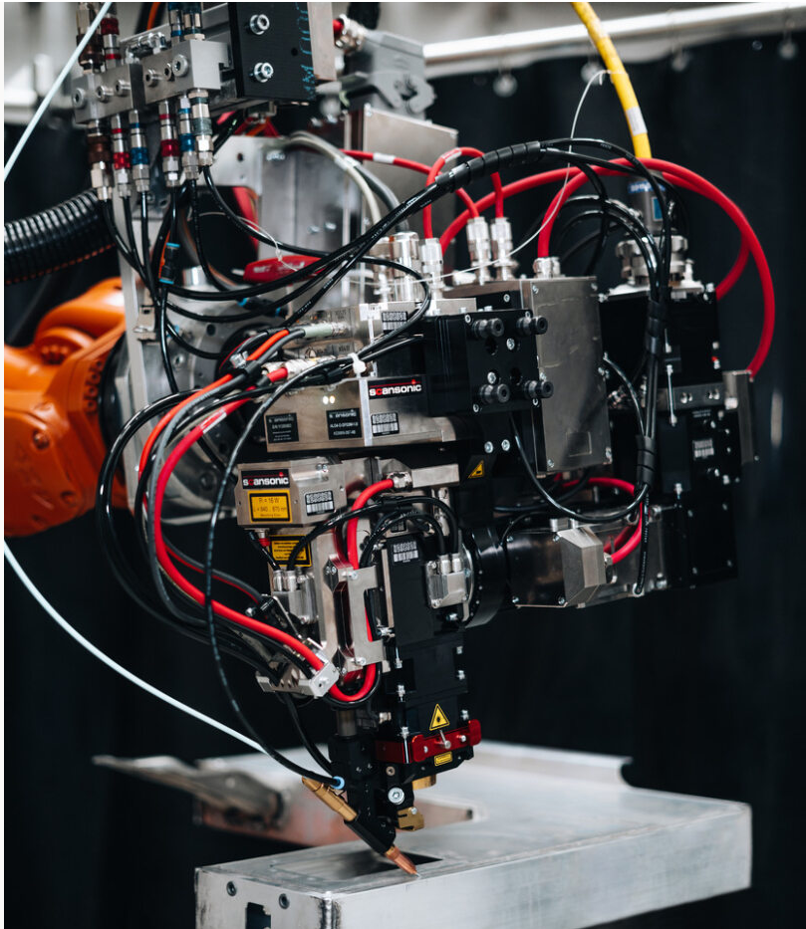

The ALO4-O was specifically developed for battery housing production. The laser processing head combines tactile seam tracking with laser beam oscillation typically found in remote optics.

*Copyright Scansonic MI GmbH*

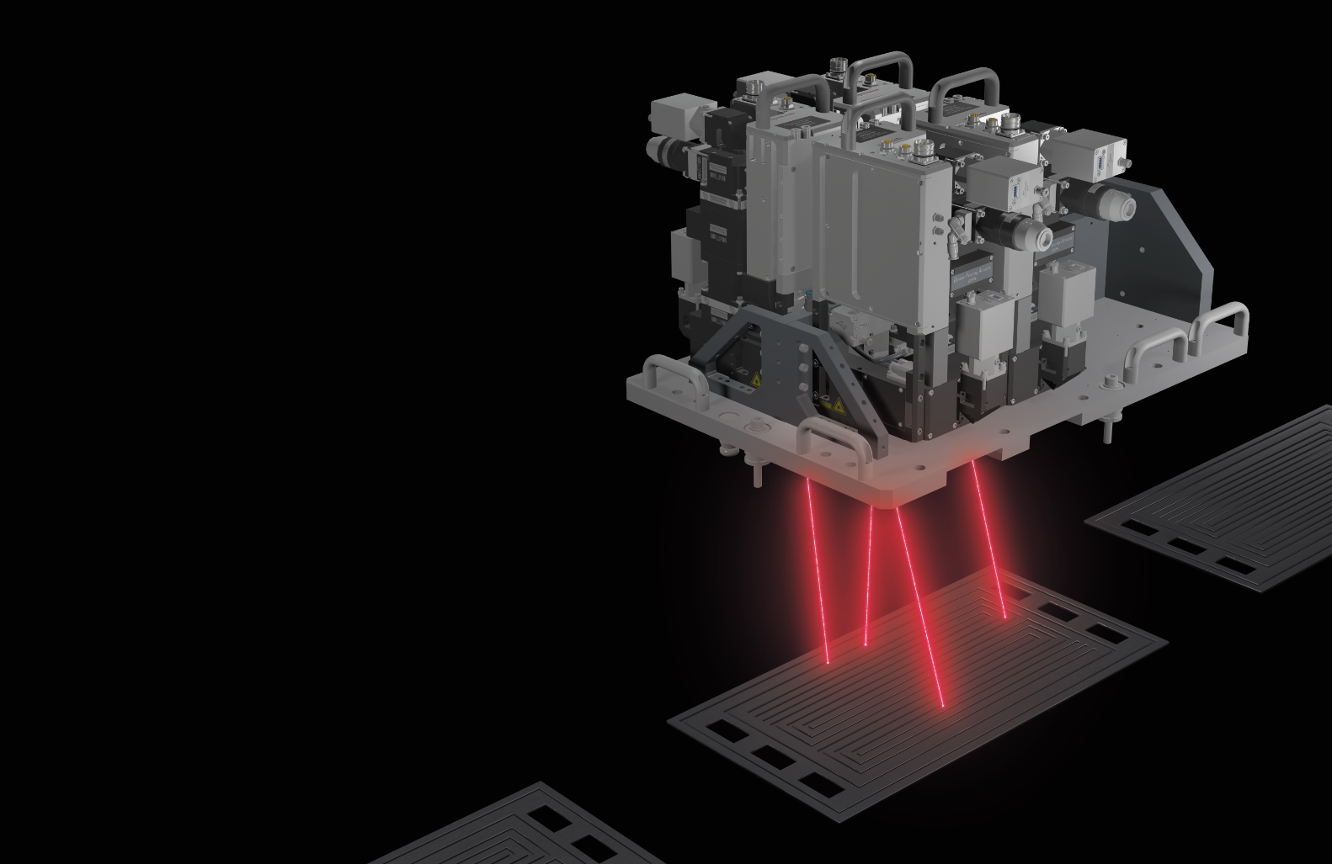

With the new FCW system, Scansonic responds to the increasing demands for speed and quality in laser processing, for example, in laser welding of battery contacts, bipolar plates, hairpins, or surface coolers for automotive battery trays in electric vehicle powertrains.

*Copyright Scansonic MI GmbH*

Ein Bild, das Maßstabsmodell, Spielzeug enthält.

In the FCW system, five scanner units are arranged on a single application plate. They enable parallel welding, significantly increasing process speed.

*Copyright Scansonic MI GmbH*

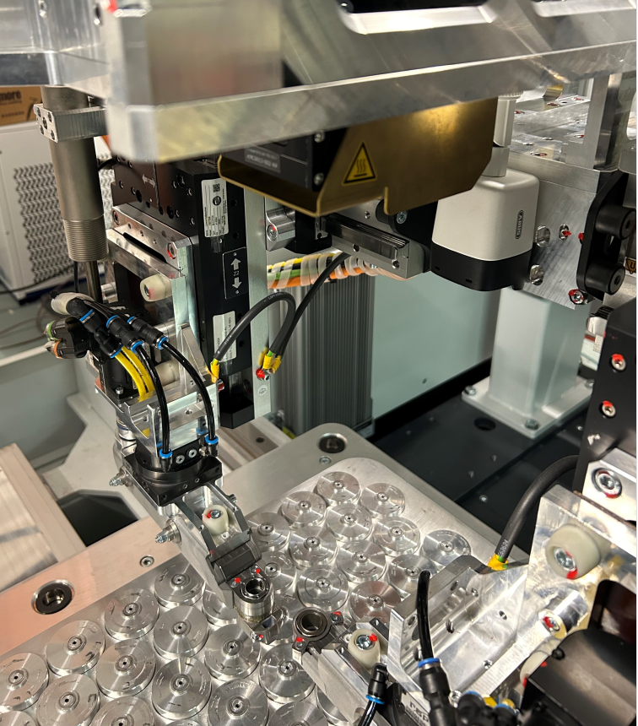

By combining two clamping fixtures with the FCW welding optics, the Scanwalker system from Bergmann & Steffen offers a complete solution and achieves high production speeds.

*Coypright: Bergmann & Steffen GmbH*